SPECIFICATIONS OF THE BRANDED MERCHANDISE
S/NO. | ITEM DESCRIPTION | SPECIFICATIONS
1. | Branded Shirts and blouses.  Shirts- 700  Blouses- 300  Quantity -1000 | Men Shirts:  - One (1) breast pocket placed on left side and embroidered with KEMFSED logo in full color  - Short Sleeved  - Fused collar  - Blue inner lining for collar and sleeves  - Double stitched seams  - Chunky white shirt buttons with four (4) holes  - Classic fit shirt  Women Blouses:  - 3/4 sleeved button down  - Double button cuffs  - Fashion collar  - Blue inner lining for collar and sleeves  - Concealed front fastening  - Double stitched seams  - Chunky white shirt buttons with four (4) holes  - Contoured hemline  - Classic fit shirt; shaped body  - Embroidered with KEMFSED logo in full color on the upper left of the blouse.
2. | Branded T-shirts-polo 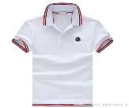  Men-700  Ladies-300  Quantity-1000 | - Design & Production of custom-made polo T-shirts white and blue KEMFSED colours  - Material: 100% cotton, 240gms  - Pattern: Embroidered KEMFSED logo (front) Embroidered KEMFSED slogan (back)  - Collar with buttons and Side bands  Sleeves: Short sleeves & ladies should be shaped
3. | Branded Caps  Quantity- 1000 | - Material: Twill Cotton 100%  - Pattern: Embroidered KEMFSED logo (front)  - Colour: White
4. | Branded Lesos  Quantity-1000  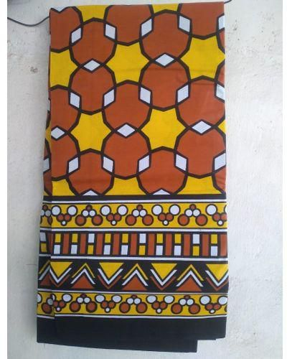 | - Size (LxW) 340cmx110cm  - Weight in kgs:0.35  - Main Material; Cotton 100%  - Printed with KEMFSED logo and slogan
5. | Branded Kikoys-Quantity 1000  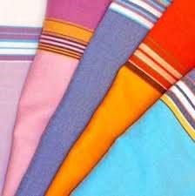 | - Finish: Perfect finish  - Style: Trendy & stylish  - Material: 100% Turkish cotton  - Dimensions: 73 x 36 inches  - Embroidered KEMFSED Logo  - Stitch an addition of fleece to the inner side of the kikoy
6. | Branded Reflectors  Quantity- 1000 | - 100% polyester with sturdy highly breathable light weight for air circulation and fast drying mesh type material.  - KEMFSED logo embroidered onto garment on chest above left pocket.  - KEMFSED slogan on the back.  - Lime yellow
7. | Brochures  Quantity-1000  700-English  300-Swahili | Printing of the Brochure (English and Swahili)  - Size: (H) 8.5 in. x (W) 26 in.  - Fold: Three  - Color: Blue and White  - Type of paper: C2S 120; glossy/ laminated  - As per sample and artwork provided
8. | Banners  Quantity-12 Pcs | - White and blue in colour  - 2mx1m in size  - As per artwork provided
9. | Tear drops  Quantity-12 Pcs | - Blue and white in color  - Size 3.5m  - As per sample provided
10. | Roll-ups  Quantity-12Pcs | - White and blue in colour  - 2mx1m in size  As per artwork provided

