  Republic of Kenya | Kenya Marine Fisheries Socioeconomic Development Project (KEMFSED)  P.O. Box 58187-00200 NAIROBI | 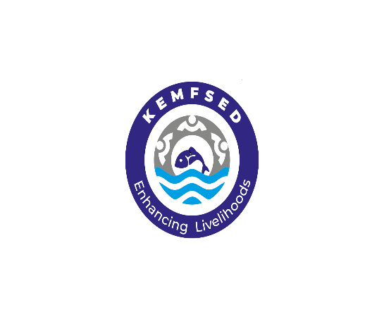
STATE DEPARTMENT OF BLUE ECONOMY AND FISHERIES

Request for Expression of Interest
(Consulting Services – Firm Selection)
Country: Kenya

Name of project: Kenya Marine Fisheries and Socio-Economic Development Project (KEMFSED)
Project No.: P163980 ; Credit No: 65400-KE

Assignment Title: Consulting Services to Undertake Beneficiary Satisfaction Survey for Kenya Marine Fisheries Socio-Economic Development (KEMFSED) Project

Contract No.: KE-MOMBEMA-C2-2024-037-CS-CQS

- This Request for Expression of Interest follows the General Procurement Notice for this project that appeared in Development Business; of 10th August 2020.

- The Government of Kenya has received a Credit from International Development Agency (IDA) towards the cost of the Kenya Marine Fisheries and Socio-Economic Development Project (KEMFSED) and intends to apply part of the proceeds of this Credit to payments under this contract: Consultancy Services to Undertake Beneficiary Satisfaction Survey for Kenya Marine Fisheries Socio-Economic Development (KEMFSED) Project. Contract No. KE-MOMBEMA-C2-2024-037-CS-CQS

- The overall objective of this assignment is to ascertain the beneficiaries’ perception on the effectiveness of the project interventions offered and the bundle of benefits derived from the project and assess their level of satisfaction with the services and products. The assignment is intended to assess one of the performance indicators in the Project Results Framework – ‘share of target beneficiaries with rating satisfied or above on the project interventions.
- The tasks to be carried out under the assignment includes but not limited to:
- Grants provided for CIG/CBO subprojects

On the grants provided for the subprojects’ implementation, assess the level of satisfaction among the beneficiaries on the following:
- Funding levels
- Subproject preparation and implementation process as guided in the Project Grant Manual (PGM)
- Technical assistance provided during implementation
- Assess the subproject procurement process
- CIG performance
- Subproject categories implemented
- Grievance redress mechanisms
- Handling of environmental and social safeguards
- Guidance provided on sustainability of the subprojects

ii) Training-related activities undertaken
In view of the training sessions conducted, the following tasks will be undertaken:
- Assess the content of all training sessions conducted against the capacity needs of the beneficiaries
- Assess the level of understanding of the subject matter among the target beneficiaries against the training content offered;
- Assess the adoption of the different technologies and practices by project beneficiaries
- Assess the level of satisfaction by recipient beneficiaries of the various training sessions conducted and the justification for the same

iii) Scholarships/Internship Programme
- Assess the coverage of the scholarships/interns within the project area;
- Assess and determine the degree of involvement of the target beneficiaries in designing the scholarship and internship programme;
- Assess and determine the degree of beneficiaries’ satisfaction with regard to the mechanism of awarding the scholarship and internship grants
- Assess the level of perception and reception of the various categories of scholarships by beneficiaries and degree of satisfaction with the same;
- Interrogate the level of satisfaction rating provided by the respondents reached.
- Reveal deficiencies and consolidate the experience in the course of the survey

Over and above the tasks raised in each of the three areas above, the survey will also establish the following from the respondents:
- What worked well and that which didn’t work well
- Critical success factors
- Recommendations from the respondents, and
- Lessons learnt.

- The Firm shall have the following qualifications:
This Assignment will be conducted by a firm with similar expereince in;
Core business and years in business: The firm shall be registered/incorporated as a consulting firm with core business in the field survey and with an understanding of beneficiary satisfaction or related fields for a period of a minimum of 10 years.

Relevant experience: The firm shall demonstrate as having successfully executed and completed at least 2 No. assignments of similar nature, complexity and in a similar operating environment in the last 5 years. Details of similar assignments- Name and address of the client, scope, value, and period should be provided in the submitted Expression of Interest including enumeration of these similar past assignments.

Technical and managerial capability of the firm: The firm shall demonstrate as having the requisite technical capacity and managerial capacity to undertake the assignment in the submitted company profile(s). Key Experts will not be evaluated at the shortlisting stage.

- The Consulting Services Contract is expected to be for a period of One Hundred and Twenty (120) Days from the date of commencement.

- The State Department of Blue Economy and Fisheries through the Kenya Marine Fisheries and Socio-Economic Development (KEMFSED) Project now invites listed firms to express their interest in providing the services. The shortlisted will focus on experience in similar assignments, Similar Environment and Availability of Key Experts among the staff

- The Consultant Firm will be selected in accordance with the Consultant Qualification Selection method (CQS) set out in the World Bank’s Procurement Regulations for IPF Borrowers dated September 2023 fifth Edition (Regulations).

- The listed Firms may obtain further information at the address below from 0900 to 1700 hours East African Time (EAT) from Monday to Friday excluding lunch hour (1300 to 1400hours EAT) and public holidays or download full TORs on Website: www.kemfsed.org

- Expression of interest shall be delivered by 14th January, 2025 at 1100 hours EAT. - using one of the following modalities: (i) deposit in the tender box located on Mezzanine Floor, Maktaba Kuu Building Opposite NHIF Ngong Road Nairobi, Kenya or (ii) send by email to: info@kemfsed.org and quote the Assignment title and Contract No. in the Subject row. For expressions of interest that will be deposited at the tender box, the packages should be clearly marked Consultancy Services to Undertake Beneficiary Satisfaction Survey for Kenya Marine Fisheries Socio-Economic Development (KEMFSED) Project; Contract No.: KE-MOMBEMA-C2-2024-037-CS-CQS

Principal Secretary
State Department for Blue Economy and Fisheries
Kenya Marine Fisheries and Socio-Economic Development (KEMFSED) Project
Maktaba Kuu Building, Mezzanine Floor, Ngong Road,
Nairobi, Kenya
Email: info@kemfsed.org
Telephone: +254-729 096 403
Website: www.kemfsed.org

NATIONAL PROJECT COORDINATOR
FOR: PRINCIPAL SECRETARY/STATE DEPARTMENT FOR BLUE ECONOMY AND FISHERIES,
KENYA MARINE FISHERIES AND SOCIO-ECONOMIC DEVELOPMENT (KEMFSED) PROJECT

