  Republic of Kenya | Kenya Marine Fisheries Socioeconomic Development Project (KEMFSED)  P.O. Box 58187-00200 NAIROBI | 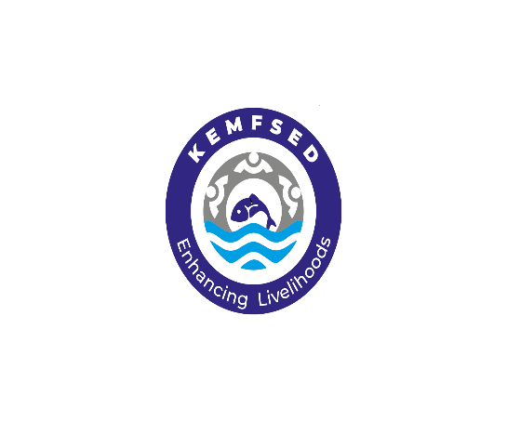
STATE DEPARTMENT OF BLUE ECONOMY AND FISHERIES

Request for Expression of Interest
(Consulting Services – Firm Selection)
Country: Kenya
Name of project: Kenya Marine Fisheries and Socio-Economic Development Project (KEMFSED)
Project No.: P163980; Credit No: 65400-KE

Assignment Title: Consulting Services for Development of Blue Economy Master Plan for Kenya
Contract No.: KE-MOMBEMA-C1-2024-038-CS-CQS

- This Request for Expression of Interest follows the General Procurement Notice for this project that appeared in Development Business; of 10th August 2020.

- The Government of Kenya has received a Credit from International Development Agency (IDA) towards the cost of the Kenya Marine Fisheries and Socio-Economic Development Project (KEMFSED) and intends to apply part of the proceeds of this Credit to payments under this contract: Consultancy Services for Development of Blue Economy Master Plan for Kenya KE-MOMBEMA-C1-2024-038-CS-CQS

- The overall objective of this consultancy is to develop a comprehensive 10-year Integrated Master Plan in order to guide and facilitate investment in the blue spaces and sustainable exploration and exploitation of blue resources to spur economic growth in Kenya.
- The tasks to be carried out under the assignment includes but not limited to:

- Develop a master plan for the blue economy sector to promote the governments development agenda on:
- harnessing the full potential of the country’s blue economy from the ocean and inland lakes;
- creating economic opportunities in priority sectors (Chapter 1.3);
- Creating jobs and inclusive growth;
- intensifying and attracting investments by the private sector in the blue economy space; and
- maintaining a healthy and functioning blue economy environment.
- Undertake a comprehensive review of relevant policies, legal, institutional and regulatory frameworks,
- Propose cost-effective fiscal and non-fiscal policies, laws and institutional reforms, capacity building or changes necessary to implement the master plan.
- Prepare an investment plan, budget and Monitoring and Evaluation (M&E) framework for the implementation of the master plan. More detailed scope is in the TORs

- The Firm shall have the following qualifications:

This Assignment will be conducted by a firm with similar expereince in;
Core business and years in business: The firm shall be registered/incorporated as a consulting firm with core business in the field natural resource management and with an understanding of Blue Economy priority sectors and especially in developing of government policies, plans, and strategies or related fields for a period of a minimum of 15 years.

Relevant experience: The firm shall demonstrate as having successfully executed and completed at least 2 No. assignments of similar nature, complexity and in a similar operating environment in the last 10 years. Details of similar assignments-Name and address of the client, scope, value, and period should be provided in the submitted Expression of Interest including enumeration of these similar past assignments.

Technical and managerial capability of the firm: The firm shall demonstrate as having the requisite technical capacity and managerial capacity to undertake the assignment in the submitted company profile(s).
The comprisition of a multi-disciplinary team as ioutlined in the TORs attached

- The Consulting Services Contract is expected to be for a period of Nine (9) Months from the date of commencement.

- The State Department of Blue Economy and Fisheries through the Kenya Marine Fisheries and Socio-Economic Development (KEMFSED) Project now invites listed firms to express their interest in providing the services. The shortlisting will focus on experience in similar assignments, Similar Environment and Availability of Key Experts among the staff

- The Consultant Firm will be selected in accordance with the Consultant Qualification Selection method (CQS) set out in the World Bank’s Procurement Regulations for IPF Borrowers dated September 2023 fifth Edition (Regulations).

- The listed Firms may obtain further information at the address below from 0900 to 1700 hours East African Time (EAT) from Monday to Friday excluding lunch hour (1300 to 1400hours EAT) and public holidays or download full TORs on Website: www.kemfsed.org

- Expression of interest shall be delivered by 14th January, 2025 at 1100 hours EAT. - using one of the following modalities: (i) deposit in the tender box located on Mezzanine Floor, Maktaba Kuu Building Opposite NHIF Ngong Road Nairobi, Kenya or (ii) send by email to: info@kemfsed.org and quote the Assignment title and Contract No. in the Subject row. For expressions of interest that will be deposited at the tender box, the packages should be clearly marked Consultancy Services for Development of Blue Economy Master Plan for Kenya; Contract No.: KE-MOMBEMA-C1-2024-038-CS-CQS

Principal Secretary
State Department for Blue Economy and Fisheries
Kenya Marine Fisheries and Socio-Economic Development (KEMFSED) Project
Maktaba Kuu Building, Mezzanine Floor, Ngong Road,
Nairobi, Kenya
Email: info@kemfsed.org
Telephone: +254-729 096 403
Website: www.kemfsed.org

NATIONAL PROJECT COORDINATOR
FOR: PRINCIPAL SECRETARY/STATE DEPARTMENT FOR BLUE ECONOMY AND FISHERIES,
KENYA MARINE FISHERIES AND SOCIO-ECONOMIC DEVELOPMENT (KEMFSED) PROJECT

